Random forests:
The number of features that can be searched at each split point (m) must be specified as a parameter to the algorithm.
According to most papers, for regression a good default is: m = p/3
Where m is the number of randomly selected features that can be searched at a split point and p is the number of input variables.
According to experiments on our data:
The optimal no of features that can be searched at each split point (m)= p/4
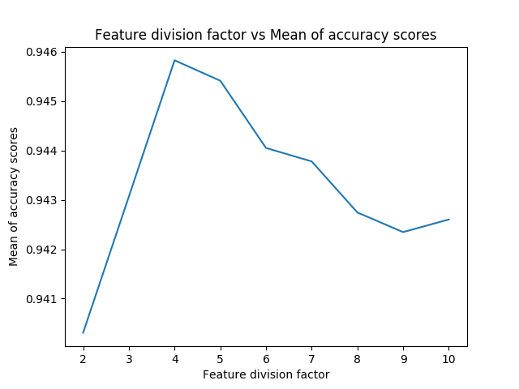
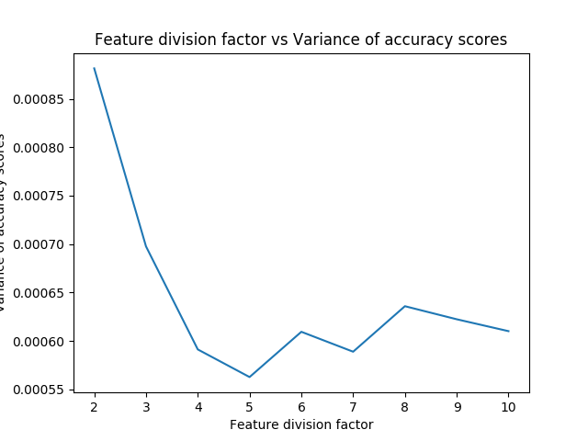
The above graphs were derived as:
For each division factor from 2 to 10, we ran 40 experiments to calculate the mean and variance of accuracy scores.
As we can see from above graph, mean of accuracy scores is highest at 4. Also, the variance of accuracy scores is the 2nd lowest at 4. Low variance and high mean in accuracy scores are desirable factors for all machine learning models

Bagged decision trees:
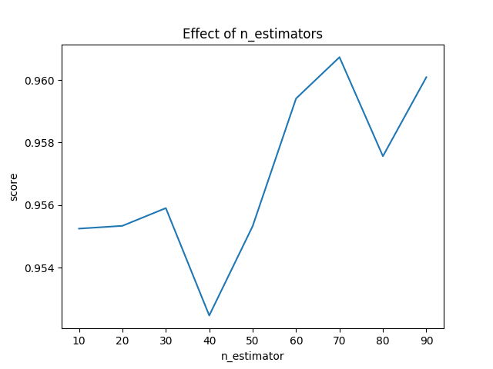

For our model, we have chosen the value of n_estimators i.e the no of decision trees used by the random forest regressor as 30 since even though, the value of accuracy score (as shown by above graph) is highest for n_estimators as 70 but it takes a lot of time.

K Nearest Neighbors:
Highest score when the algorithm uses 3 neighbours
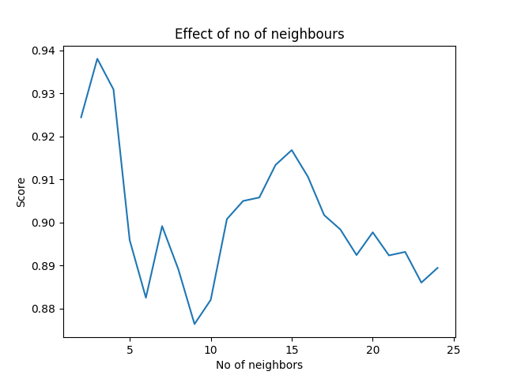

Gradient Boosting:
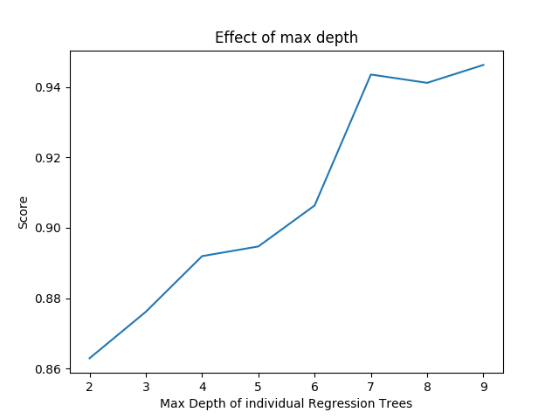

As can be seen from above graph, max depth is usually higher for values greater than 4 but we choose max depth as 4 since it is significantly faster.

XGBoost:
